Environment Setup, Project Structure & First Component
Task 1: Scaffold and Explore the Angular Project
Goal: Create the Angular workspace and understand what each generated file does.
Project Initialization:
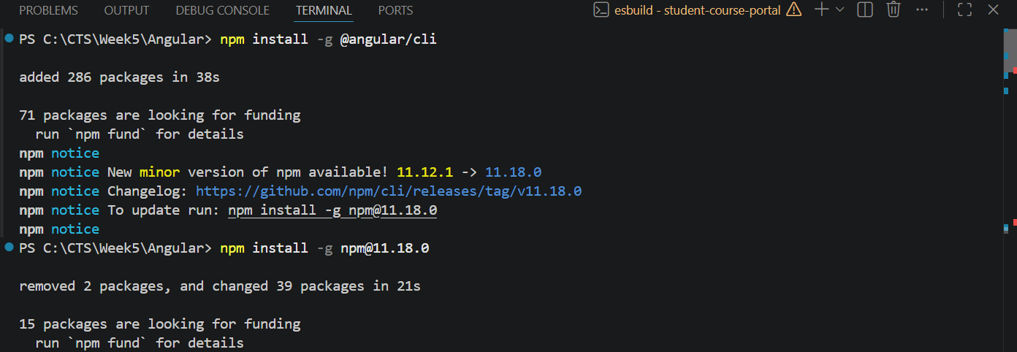
student-course-portal creation:
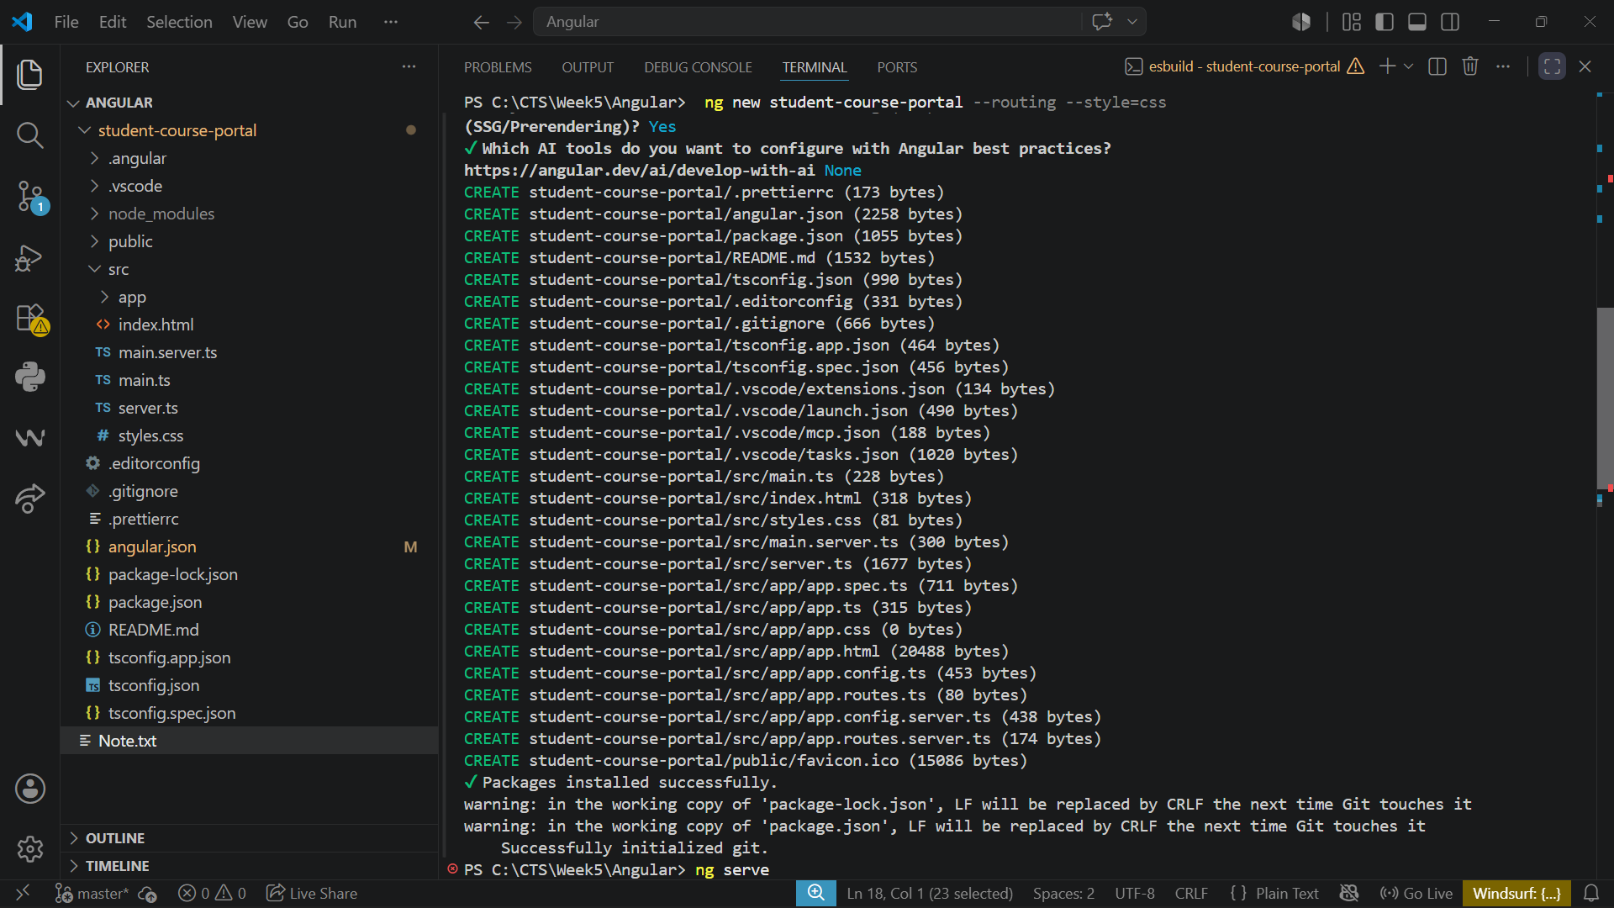

Execution:
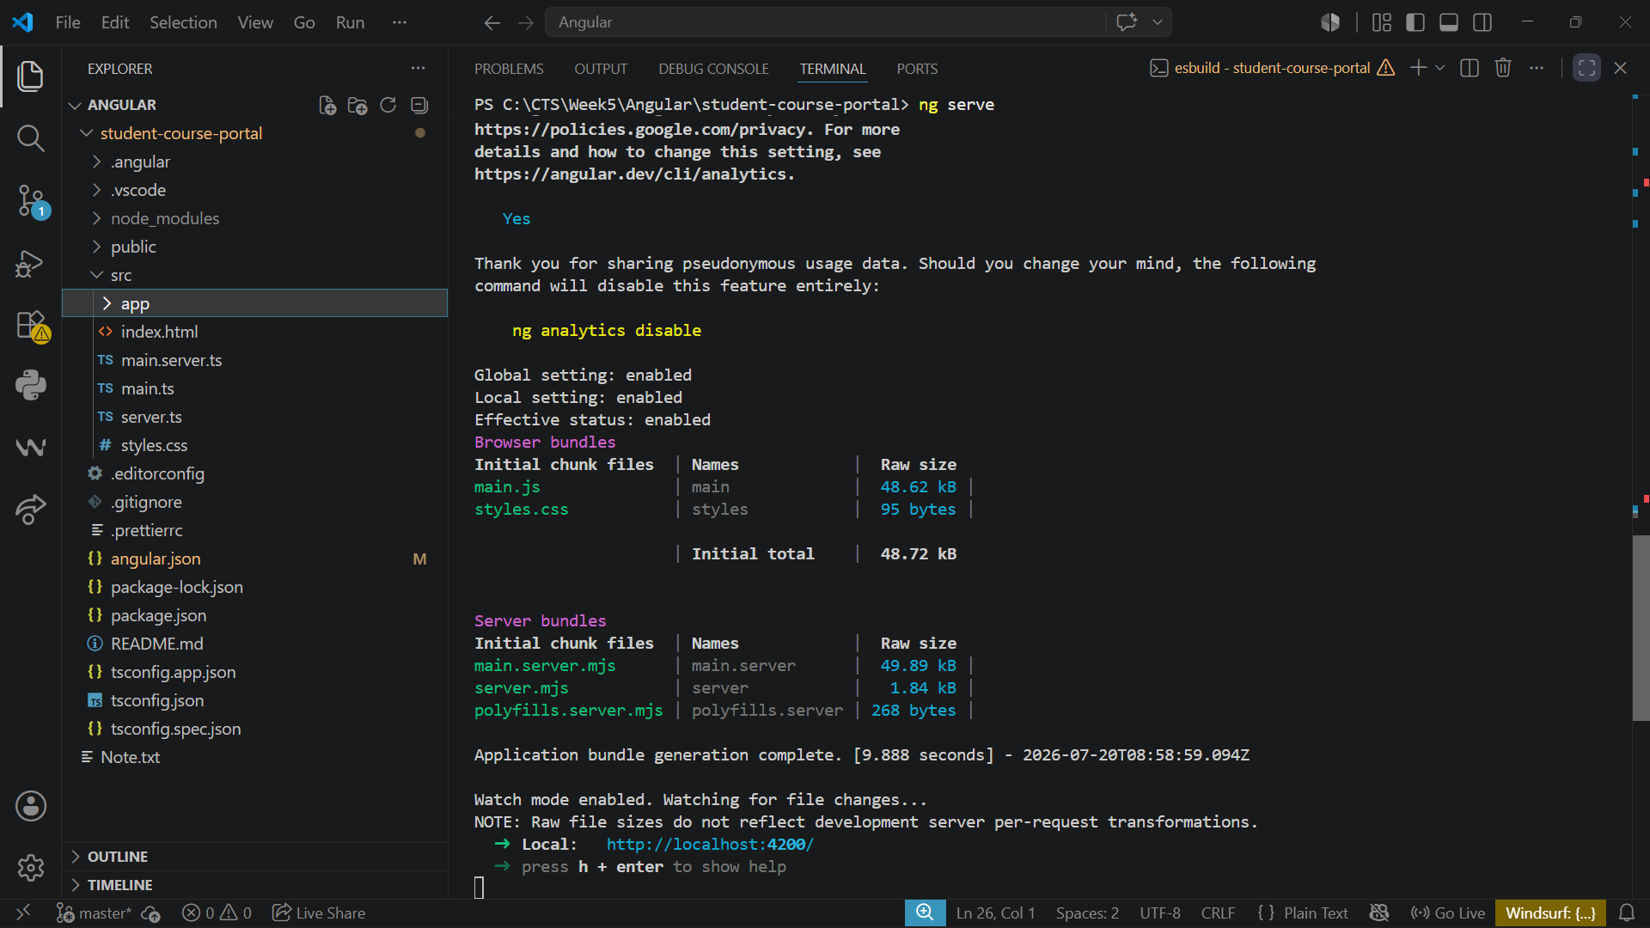
Note.txt:
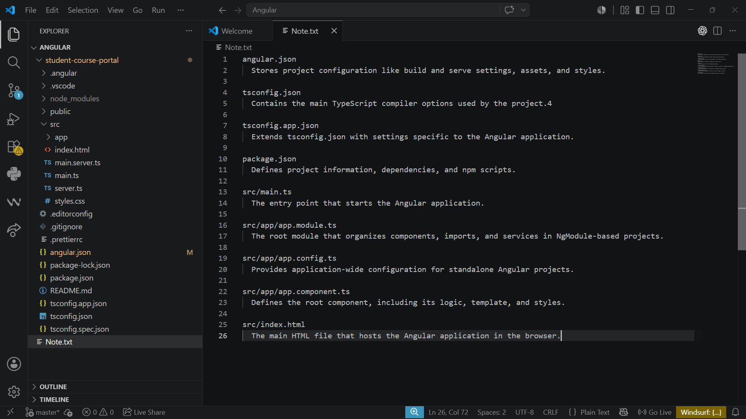

Output:
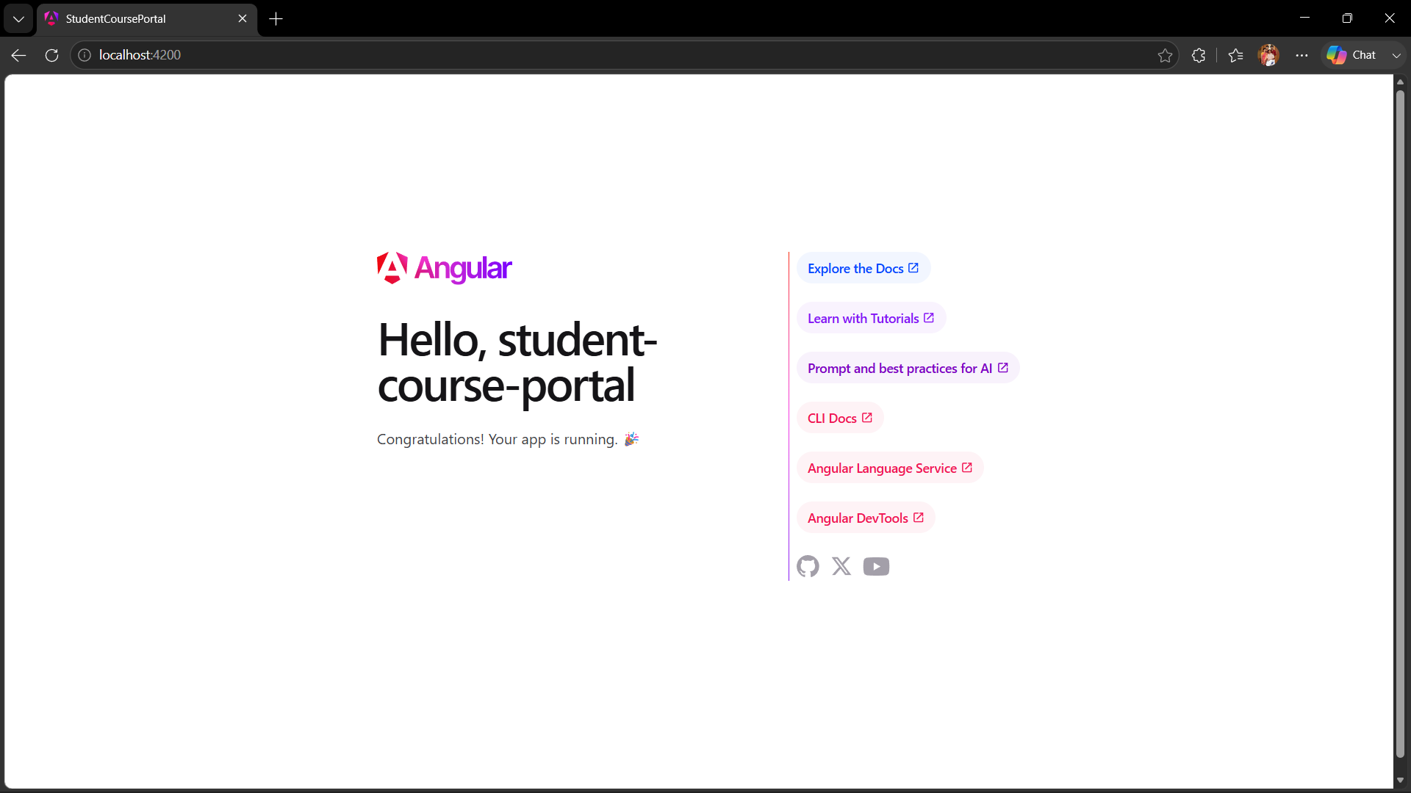

Task 2: Create and Organise Components
Goal: Generate the core page components for the Student Course Portal
Generating four components using Angular CLI:
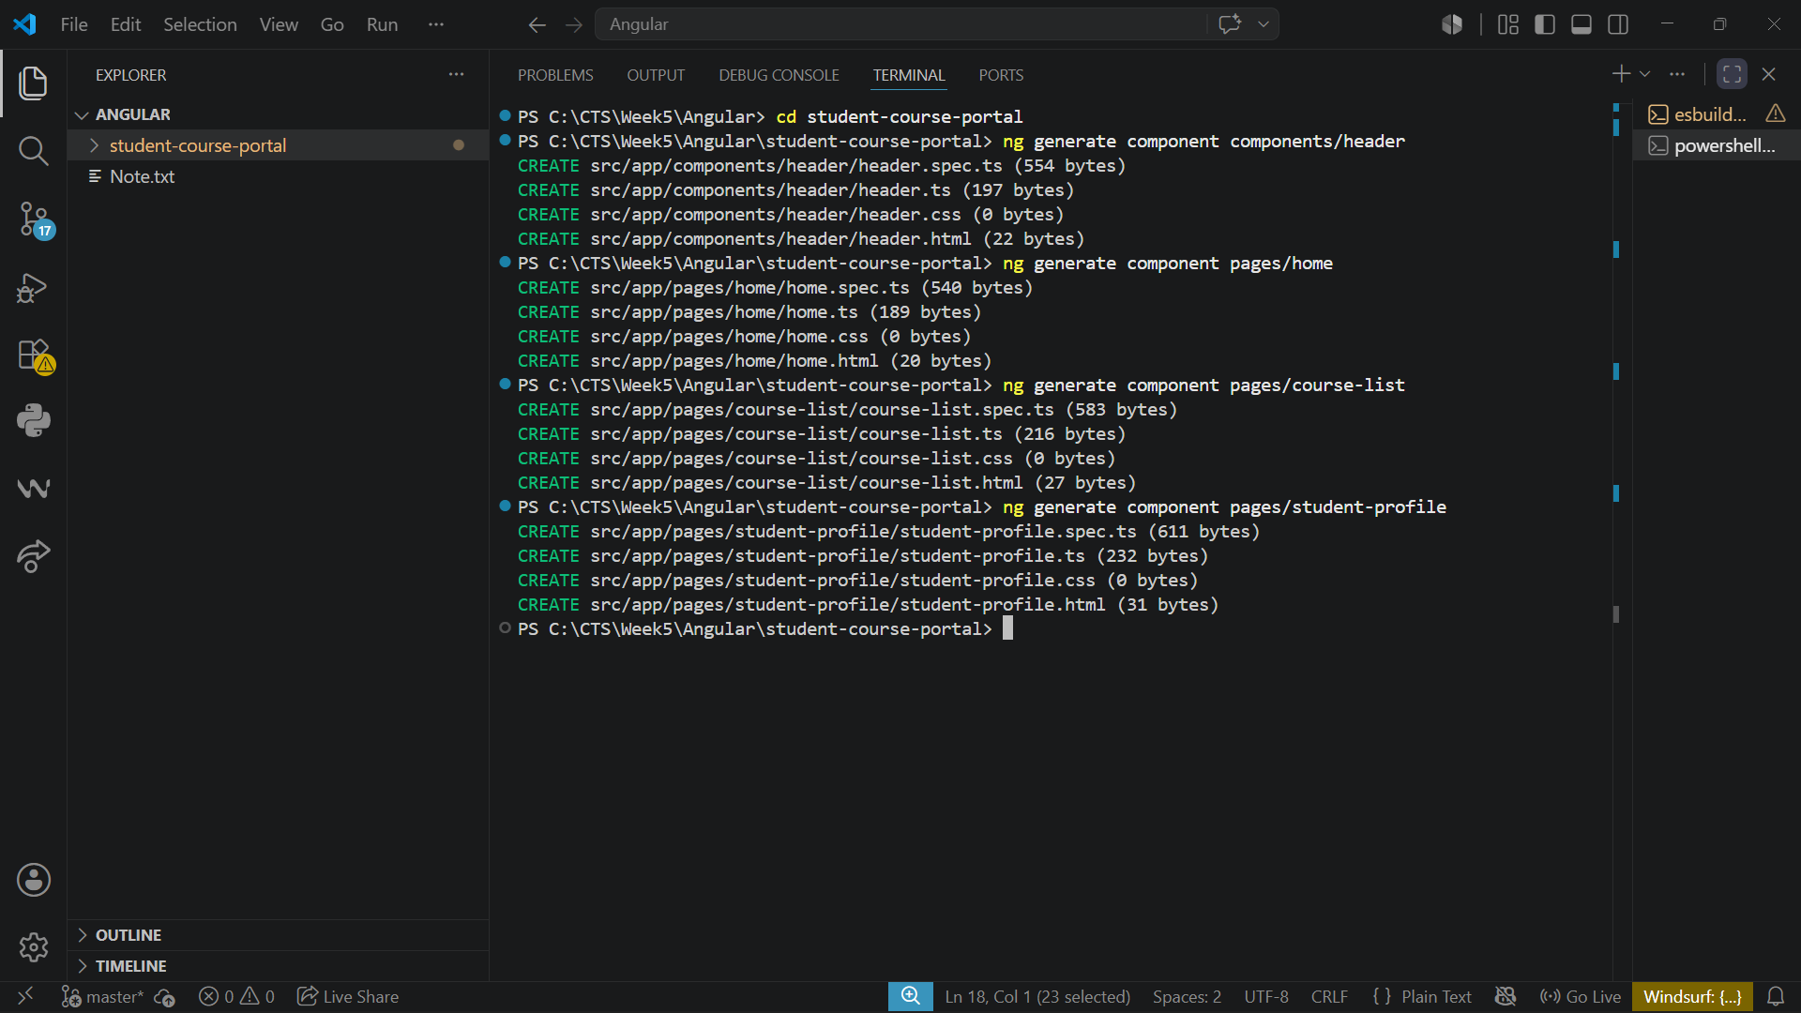
Header.html:
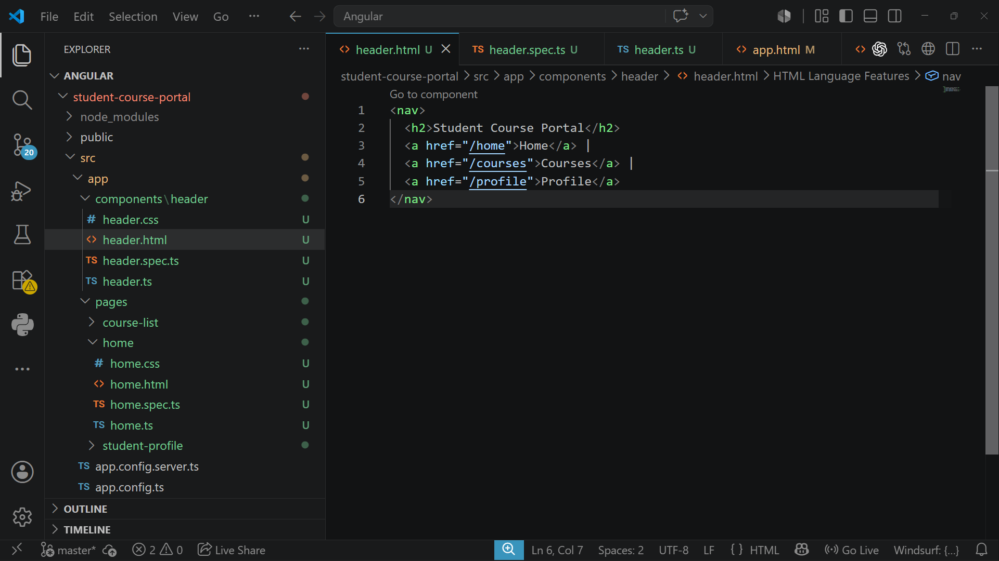

Home Page
home.html:
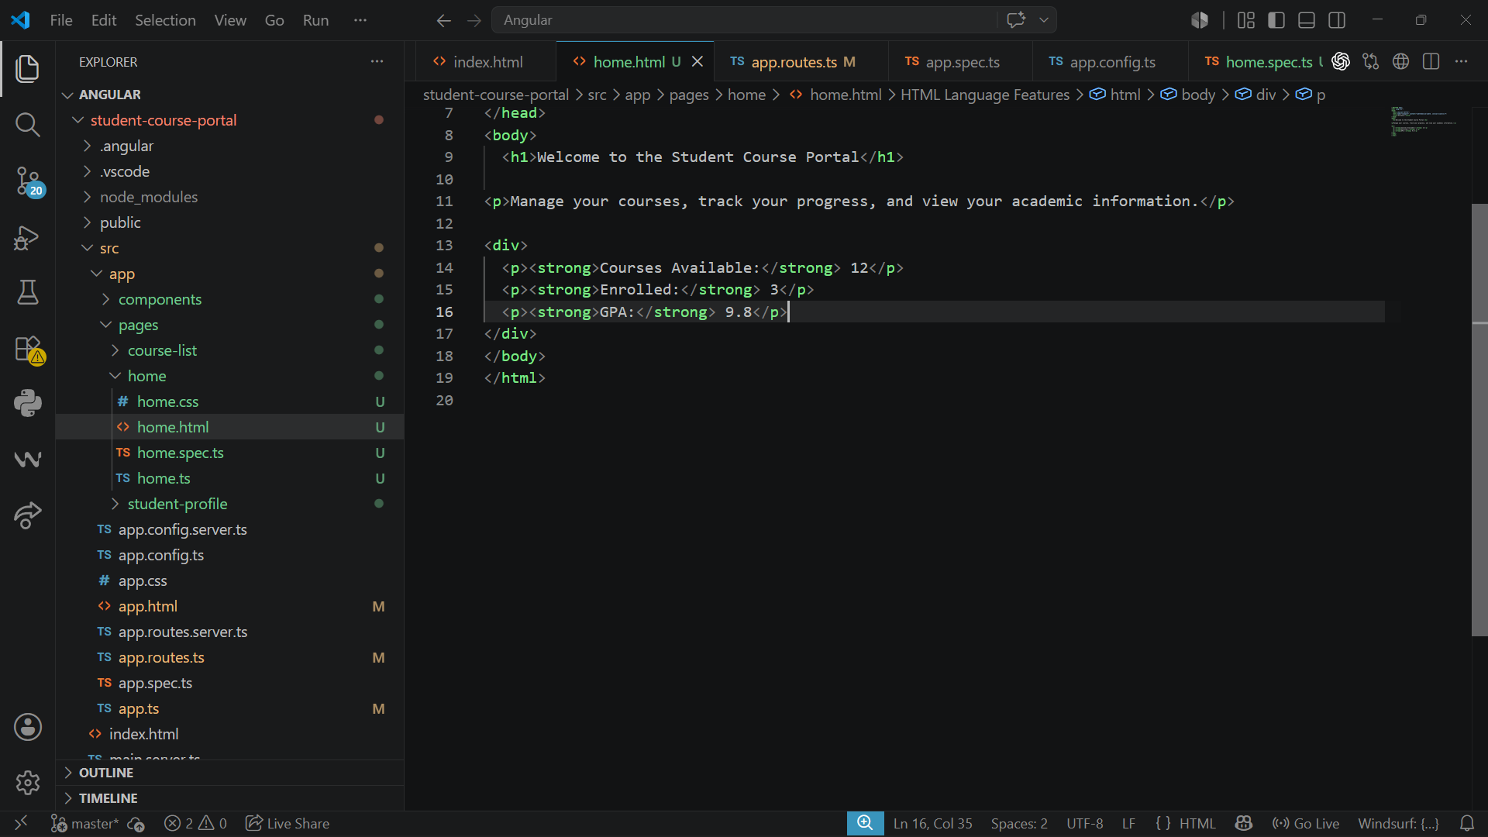
app.html:
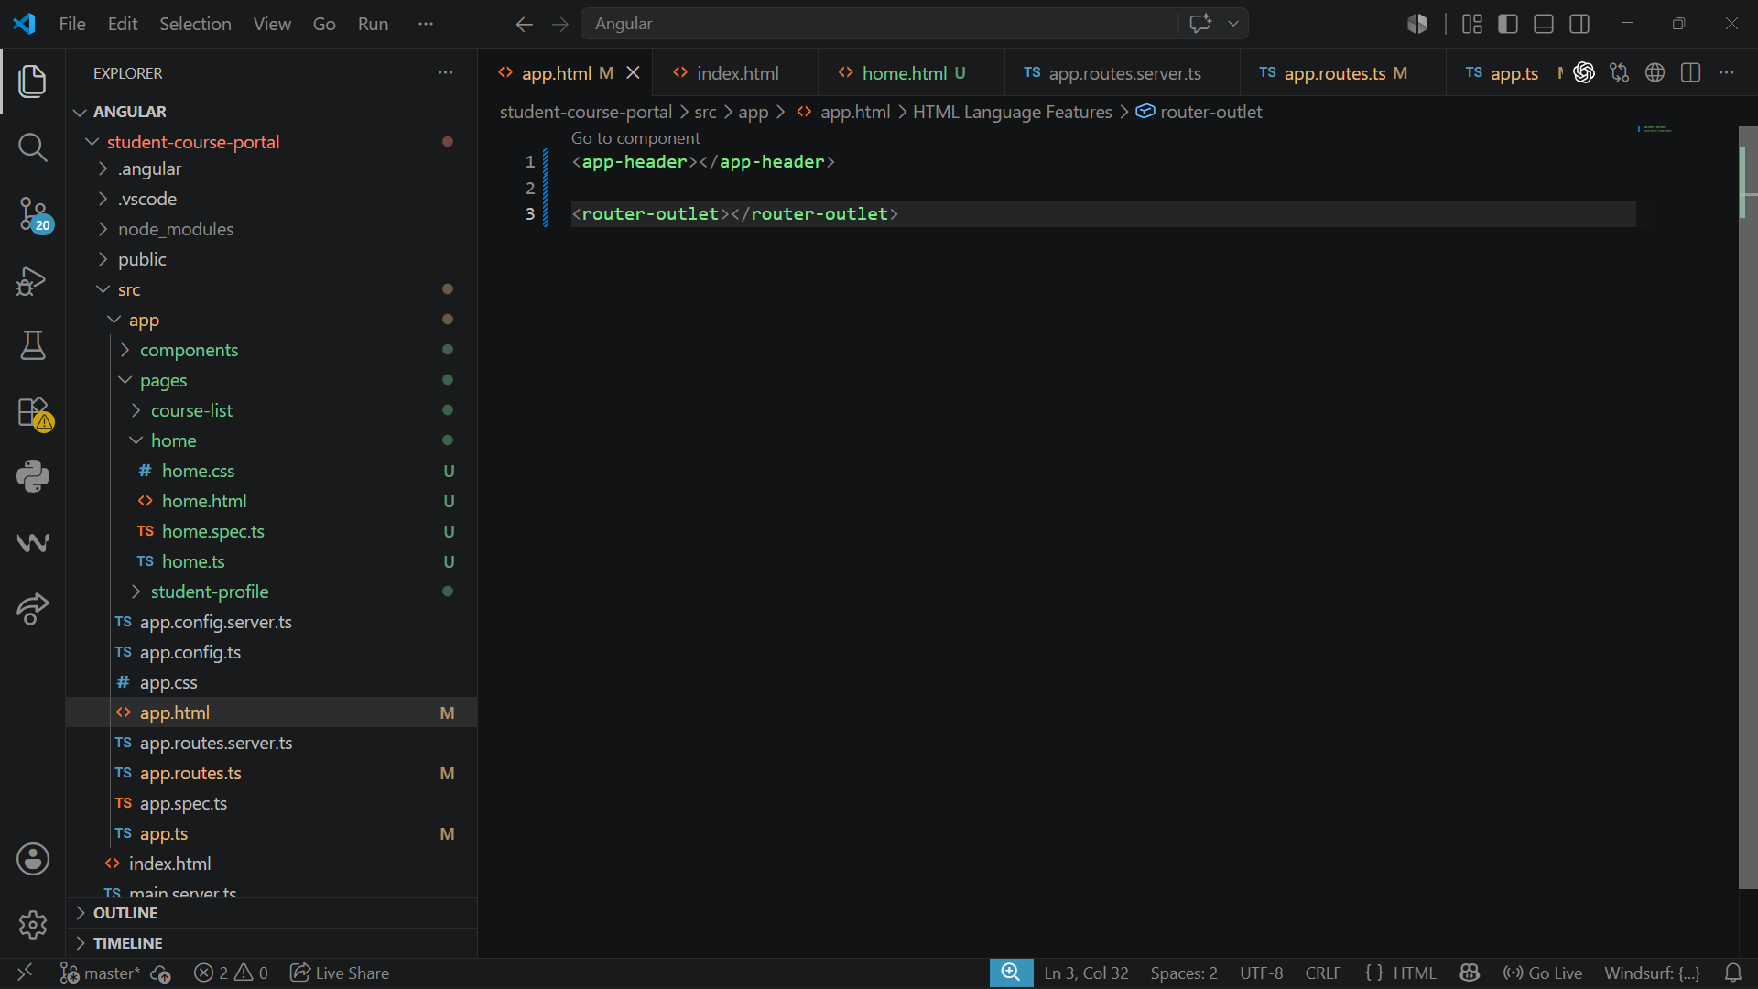

Output:
